Instructions for Renewing your WACADA Membership
- Login to the WACADA website. The “Login” button is located on the top right corner of the WACADA homepage. If you do not remember your password, click “Lost your password?” and follow the prompts.
- Click the “Join” button on the WACADA homepage.
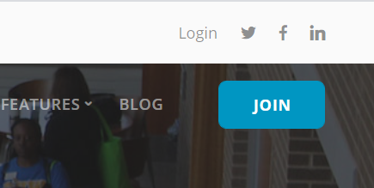
- On the left side, under “Ready to Join”, click the “Select a Level” button.
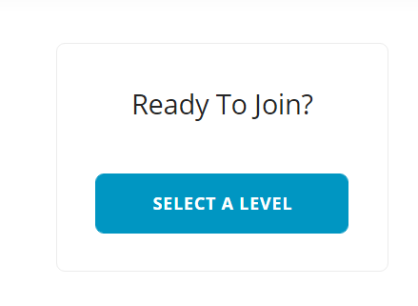
- Select your preferred payment method (PayPal or Check).
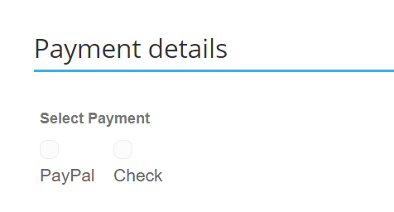
- Select your membership level.
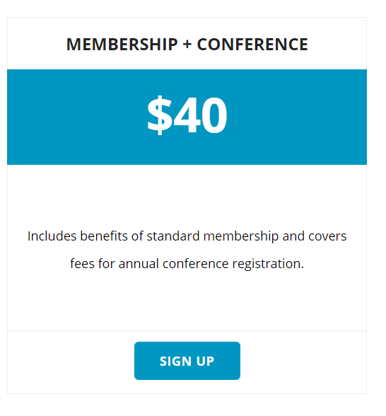
This will complete your registration!

Instructions for New Members:
- Click the “Join” button on the WACADA homepage.
- On the left side, under “Ready to Join”, click the “Select a Level” button.
- Select your membership level.
- Complete the registration information form and set up an account.
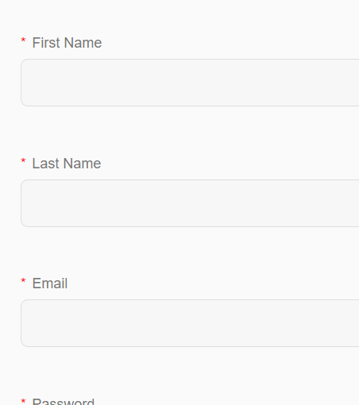
- Select payment type.
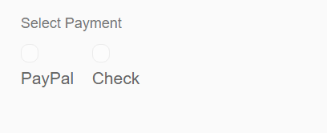
- Complete your registration and login using your new credentials.

